**GC-MS Methods MassHunter Setup:**

1. Select *New Method* from the file pull down or using the icon on the dashboard

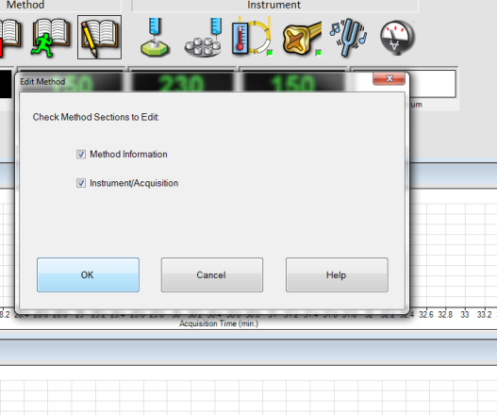

1. In the methods comments section add a brief description: SPME fiber used, ionization type, injection port type, etc
2. Pre-run Macros are subroutines that can be built into the Method. Used to accomplish tasks associated with the Method.
3. Data acquisition and Data analysis need to be checked to generate a gram.

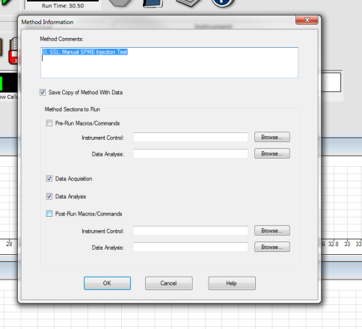

1. Injection parameters allows the selection of the physical oven, injection source, inlet port location, and MS port location

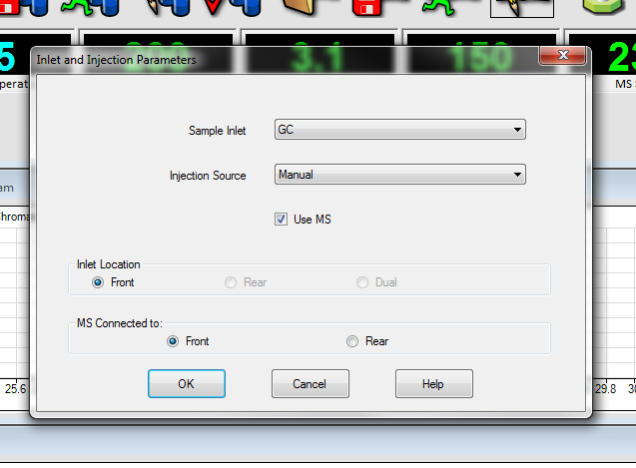

1. ALS: auto liquid sampler. When using this type of sampler wash types and washing solvent location can be selected and amounts can be selected. Sample injection size can be selected.

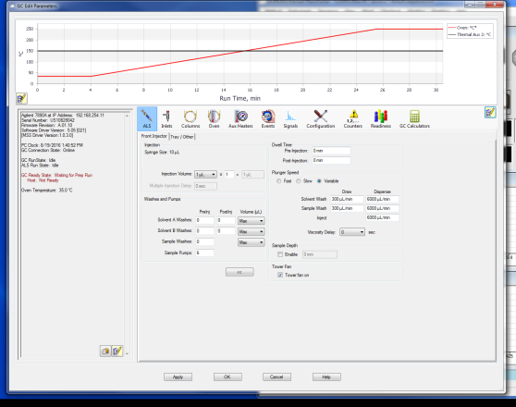

1. Inlets: the type of inlet can be selected (Split-Splitless or Cool on Column). SSL can either push all of the inlet-sample through the column (splitless) or it can purge a relative amount away from the column (split). COC put the sample directly onto the column. This requires a 0.5 column (to accommodate the syringe). Inlet temperature and pressure can be selected

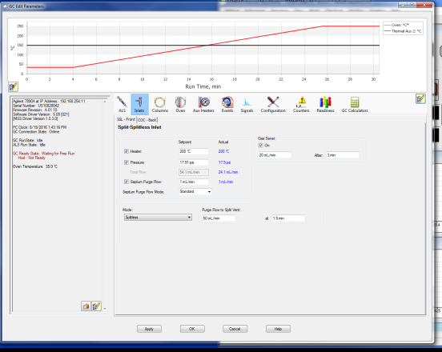

1. Column allows for the selection of: constant flow, constant pressure, flow, pressure, and column replacement and calibration

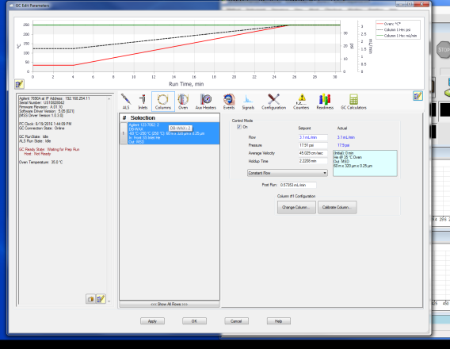

1. Oven allows the selection of the current oven status (temperature, equilibrium time, max column temp). Also allows for the selection of run parameters (initial temp and time, ramp rate, ramp temp, and post ramp hold time). Also post run temp and time at temp.

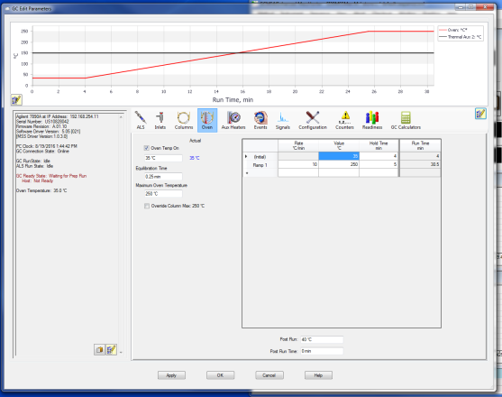

1. Aux heaters: this allows for the selection of the temperature for the heater line between the oven and the MSD

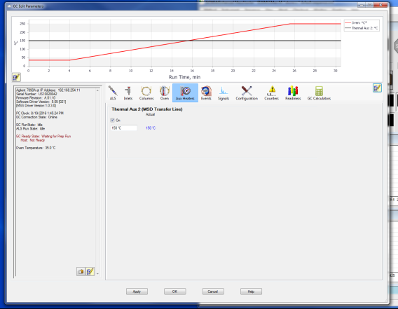

1. (Funct to be determined)

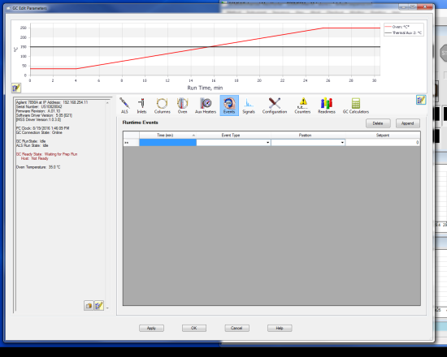

1. (Funct to be determined)

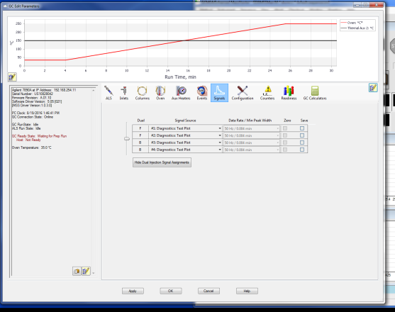

1. ???

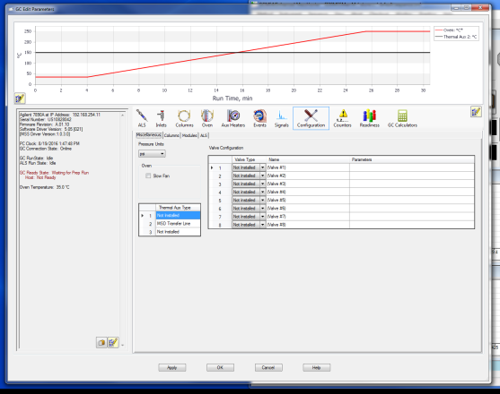

1. Config: Columns: Allows for the replacement and calibration of the column

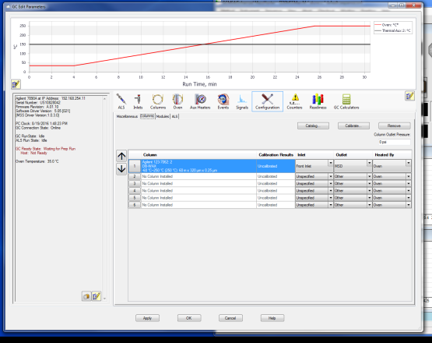

1. Allows for the selection of the carrier gas type for each inlet

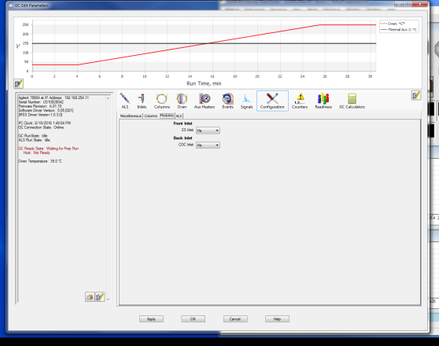

1. Configuration: ALS: Select syringe injection amount and wash solvent locations

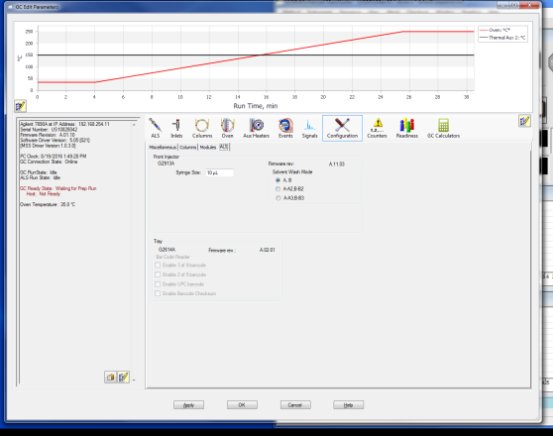

1. Counters: counts replacements and adjustments

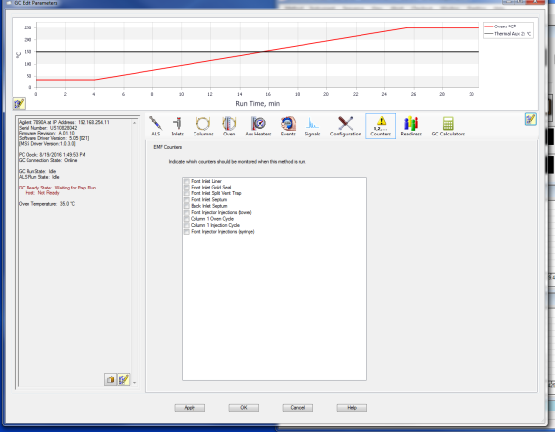

1. Readiness: Parts of the instrument that are to be checked before each run

